Meeting Location

1118 Student Innovation Center

606 Bissell Road

Ames, IA 50011

Parking:

* Lot 21 which is on the West side of Armory Building 2519 Osborn Road Ames, IA 50011   
  (2 minute walk to the meeting location)   
  Here is a link about how to pay: <https://www.parking.iastate.edu/meters>
* Ramp attached to the Memorial Union 2229 Lincoln Way Ames, IA 50011   
  (10 minute walk to the meeting location)   
  Retrieve a ticket upon entry and you pay in the building with a credit card prior to exiting.

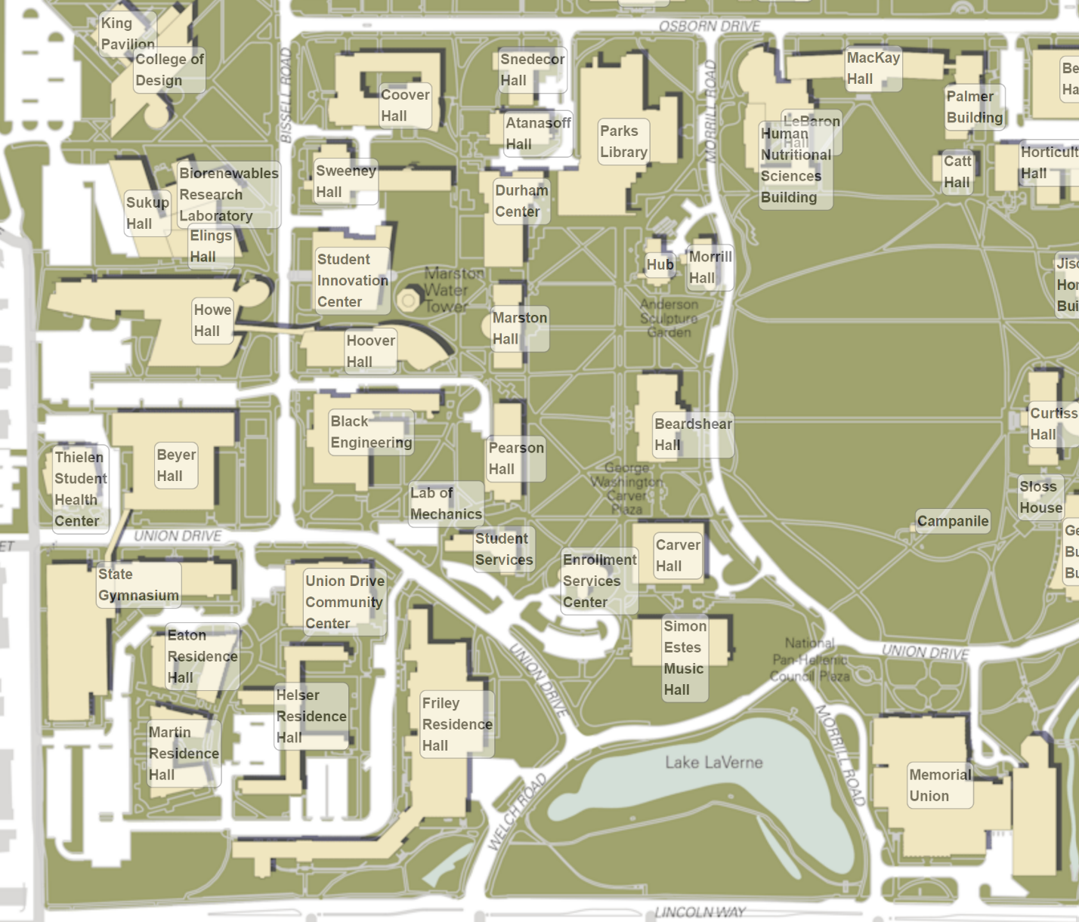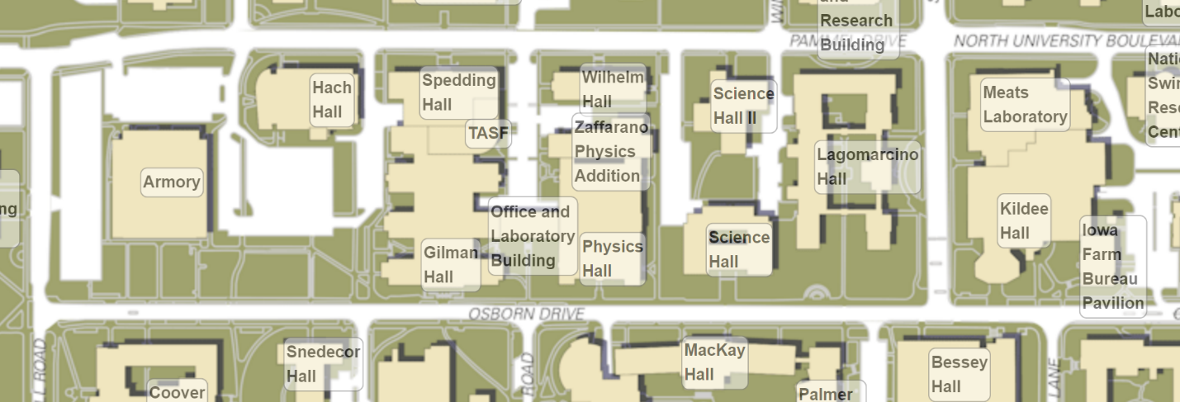

Memorial Union Parking Ramp

Meeting Location

Lot 21 - Parking